# **User Group Profile**

### Demographics: College students, single individuals, inexperienced cooks, ages 18–26; Potluck participants, new renters, budget-conscious individuals.

### Pain Points: Unsure how long homemade or leftover foods remain safe, waste food due to uncertainty, even when it may still be safe, and risk illness from improperly stored food.

### Habits & Channels: Stores leftovers without a clear system (same time for all foods), regular smartphone users (high comfort level), and discover apps primarily via app stores, TikTok, or word-of-mouth among peers.

### User Persona (Example): **Name:** Camden Lazlo, 21, student in Murray, KY. **Goals:** Stretch meals, avoid spoiled food, maximize tight budget. **Frustrations:** Tosses leftovers due to uncertainty, wastes food despite low income. **Tech Level:** High (smartphone daily, laptop for school/gaming).

### Evidence of Problem: **VeryWell Health (Brown, 2023)**: improper rice storage poses food safety risks, **FoodSafety.gov**: Cold storage times vary widely; indefinite freezing affects quality, and **Azanaw et al. (2019):** Only 19% of college students correctly answered leftover safety questions.

### **Market Size and Opportunity**

Data and Demand

The U.S. population in 2025 is about 347 million, with roughly 35 million people aged 18–26. This group represents the primary target audience, since many are college students or young adults living independently. While not all of them actively cook or manage leftovers, research suggests about 60% regularly handle non-packaged food. For revenue modeling, a freemium model with an average revenue per paying user (ARPU) of $20–30 per year is assumed. Market segmentation accounts for broader reach (TAM), the subset of college students and frequent leftover users (SAM), and a realistic early-stage penetration (SOM).

Market Size Estimates

| Market | Estimate | Description |
| --- | --- | --- |
| Total Addressable Market (TAM) | ≈ US$ 700 million – US$1 billion / year | If all ~35 million U.S. 18-26 year olds use the app, and perhaps 50% convert to paying features (optimistically), at ARPU of ~$20-30, get: 35 M × 0.5 × $25 = ~$437.5 M. If ARPU or conversion higher (or includes global market), could push toward ~$1B. |
| Serviceable Available Market(SAM) | ≈ US$ 200-300 million / year | Focused on U.S. college students & young adults who cook / use leftovers frequently, say ~40% of the 18-26 cohort: ~14 million. With realistic conversion (say 20-30%) and ARPU ~$25: 14 M × 0.25 × $25 ≈ $87.5 M; but adding in non-college young adults who cook, could bring to ~$200-300 M. |
| Serviceable Obtainable Market(SOM) | ≈ US$ 20-50 million / year | In early years, aim for modest market share among SAM: maybe 5-10% conversion/acquisition of the SAM, i.e. a few million paying users. For example: 14 M × 0.05 = 700,000 paying users × $25 = ~$17.5 M; scaling to 2 million paying users gets ~$50 M. |

# **Competitor Analysis**

| **App** | **Features** | **Strengths** | **Weaknesses & customer reviews** |
| --- | --- | --- | --- |
| **NoWaste** | Inventory for fridge/freezer/pantry, barcode scanning, lists & reminders, sharing/sync across devices, recipe suggestions / “what can I make” features. (NoWaste) | Simple, focused UI for household inventory; well-known in consumer food-inventory space; barcode scanning and syncing make it convenient for packaged goods. (NoWaste) | Weakness for *homemade* / restaurant leftovers — users must manually set dates and there’s little food-safety guidance for cooked items. Reviews praise usability but note expectations around automation and update frequency (some threads/comments ask for more intelligence/automation). (Reddit) |
| **nosh** | AI-driven expiry/inventory tracking, receipt & photo scanning, recipe suggestions from current inventory, colour-coded freshness, shopping lists, usage analytics. (Nosh) | Uses ML/AI to suggest recipes and identify waste patterns; targets younger cohorts and positions itself as a modern, behaviour-change tool; has features aimed at automated logging (receipts/scan). (TechCrunch) | Smaller user base historically; still requires manual/receipt inputs for many items and doesn't provide authoritative food-safety guidance for *leftovers vs. packaged* items. Reviews and press highlight potential but limited scale and occasional data-accuracy limits. (TechCrunch) |
| **USDA FoodKeeper** | Official storage and shelf-life guidance for 400+ foods, recommended storage practices, reminders/recall notices, “Ask Karen” food-safety Q&A. (FoodSafety.gov) | Authoritative, evidence-based guidance from USDA/Cornell — strong trust/credibility for food-safety decisions (how long to keep cooked chicken, etc.). Good for reference and clear safety rules. (Cornell Chronicle) | Not an inventory/automation app — it’s a reference tool rather than one that *tracks* your specific leftovers. Users praise accuracy but note UI/feature limits (recall calendar / UI issues reported). It doesn’t automatically log homemade or restaurant leftovers or offer meal-planning by leftover. (Google Play) |

**Explicit focus on *homemade & restaurant leftovers*** — competitors focus on packaged goods or general expiry dates; few automate spoilage timelines for cooked food or takeout. (NoWaste/Nosh emphasize packaged inventory; FoodKeeper is guidance not tracking).*(NoWaste+2Nosh+2)*

**Automated / low-friction logging for leftovers** — allow quick “I cooked this” / “leftover from restaurant” photo + date + portion size flow (faster than manual add + expiry). Nosh and NoWaste offer scanning/receipt but not tailored leftover workflows.*(Google Play+1)*

**Safety-first spoilage timelines** — combine USDA-sourced safety guidance (FoodKeeper) with contextual modifiers (storage temp, container, time since cooked, reheating history) to generate personalized safe-by/use-by recommendations — useful for worried/inexperienced cooks.*(FoodSafety.gov)*

**College-friendly UX & nudges** — quick reminders, calendar integrations, push nudges timed for typical student routines, recipe conversions scaled to single portions or “use these two leftovers tonight.” Nosh targets younger users but doesn’t fully center leftover food safety for homemade/takeout.*(TechCrunch)*

**Evidence & trust layer + liability-aware language** — integrate USDA guidance and clear “safety vs quality” messaging so users trust recommendations and understand when something is a safety risk vs merely lower quality. FoodKeeper provides the evidence base but not the tracking UX.*(FoodSafety.gov)*

# **Unique Value Proposition(UVP)**

Leftover Tracker takes the guesswork out of food safety by giving young adults clear, evidence-based timelines for homemade meals and restaurant leftovers. Unlike generic food inventory apps, it combines USDA-backed safety guidance with quick, low-friction logging so users waste less, save money, and eat with confidence.

**Differentiators:**

* **Leftovers-first design** — tailored workflows for homemade meals, takeout, and gifted food rather than just packaged goods.
* **Trusted safety guidance** — integrates USDA food-safety standards into personalized spoilage alerts.
* **Student-friendly experience** — lightweight reminders, simple logging, and recipe suggestions built for busy, budget-conscious young adults.

# 

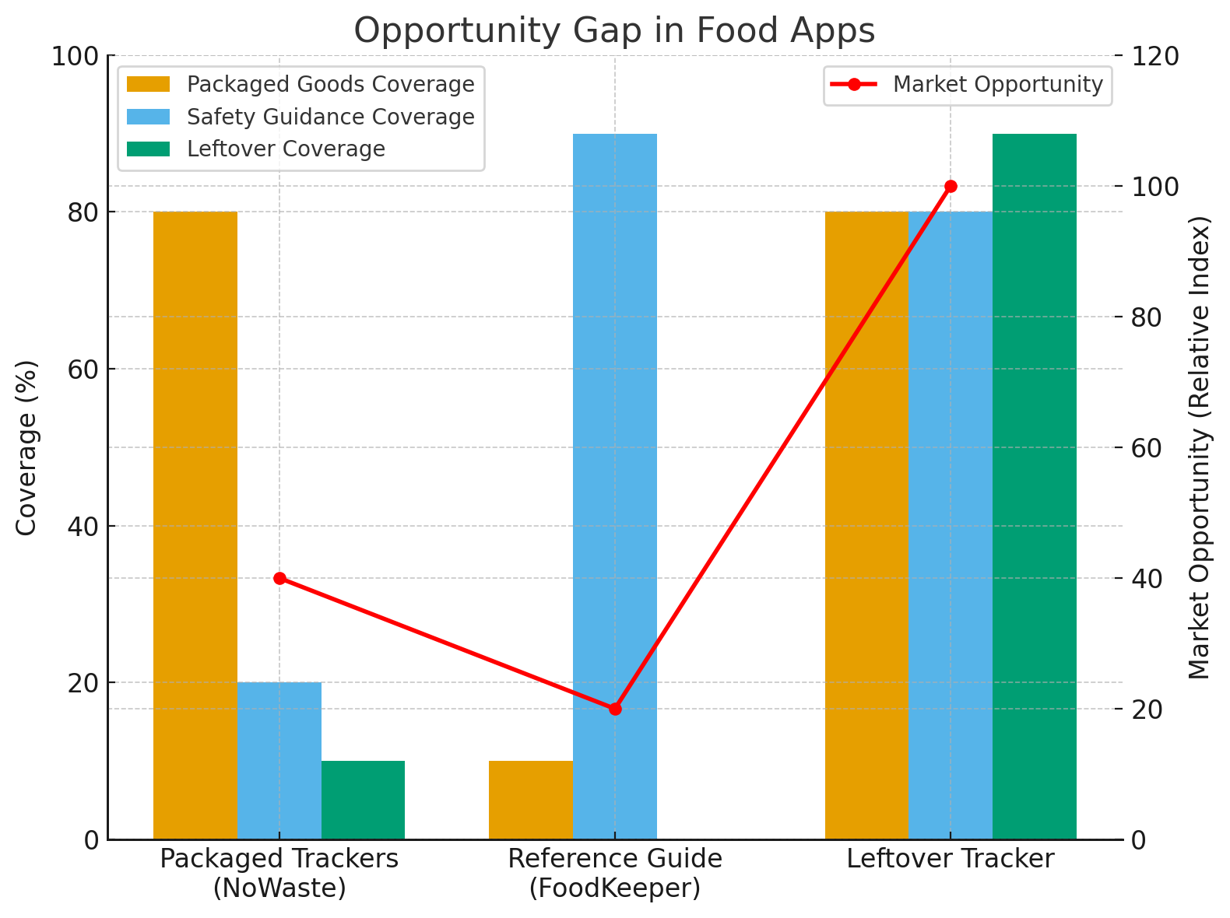

# **AI Use Section**

**Tools Used:** ChatGPT (for structuring a report and summarizing evidence).

**Prompts Used**

### *"Act as a business analyst. Estimate the total addressable market (TAM), serviceable available market (SAM), and serviceable obtainable market (SOM) for [the app idea]. Use recent statistics where possible. Present the numbers in a short paragraph followed by a 3-row table (TAM, SAM, SOM)."*

### *"You are a competitive intelligence expert. Compare 2–3 apps similar to [the app idea]. Create a table with columns for Features, Strengths, Weaknesses, and Customer Reviews. Highlight any gaps that your app could fill."*

### *"Pretend you are a startup pitch coach. Write a clear and persuasive unique value proposition (UVP) for [the app idea] in 2–3 sentences. Then, list 3 bullet points showing how it differentiates from competitors."*

### *"You are a data storyteller. Using the information from earlier slides (market size, competitor ratings, or user habits), recommend one chart or graph that best illustrates the opportunity. Provide the chart description in words and outline the key data points that should appear in the visualization."*

**Fact-checking Steps**

1. Verified food safety data with [FoodSafety.gov](http://foodsafety.gov), [VeryWell Health](https://www.verywellhealth.com/). Fact checked Competitor Analysis data using [TechCrunch](https://techcrunch.com/2021/09/23/nosh-uses-ai-to-help-people-and-businesses-cut-down-on-their-food-waste/?utm_source=chatgpt.com), [NoWaste+2Nosh+2](https://www.nowasteapp.com/?utm_source=chatgpt.com), [Google Play+1](https://play.google.com/store/apps/details?hl=en_US&id=app.F6NHQc92Bw.nosh.technologies&utm_source=chatgpt.com), [Cornell Chronicle](https://news.cornell.edu/stories/2015/04/dial-food-storage-cooking-advice-foodkeeper-app?utm_source=chatgpt.com), etc.
2. Cross-checked competitor features using official app descriptions and app store listings.
3. Used peer-reviewed study (Azanaw et al., 2019) for evidence of knowledge gaps.